Section 1
Attachment A
OneCare Vermont Board of Managers
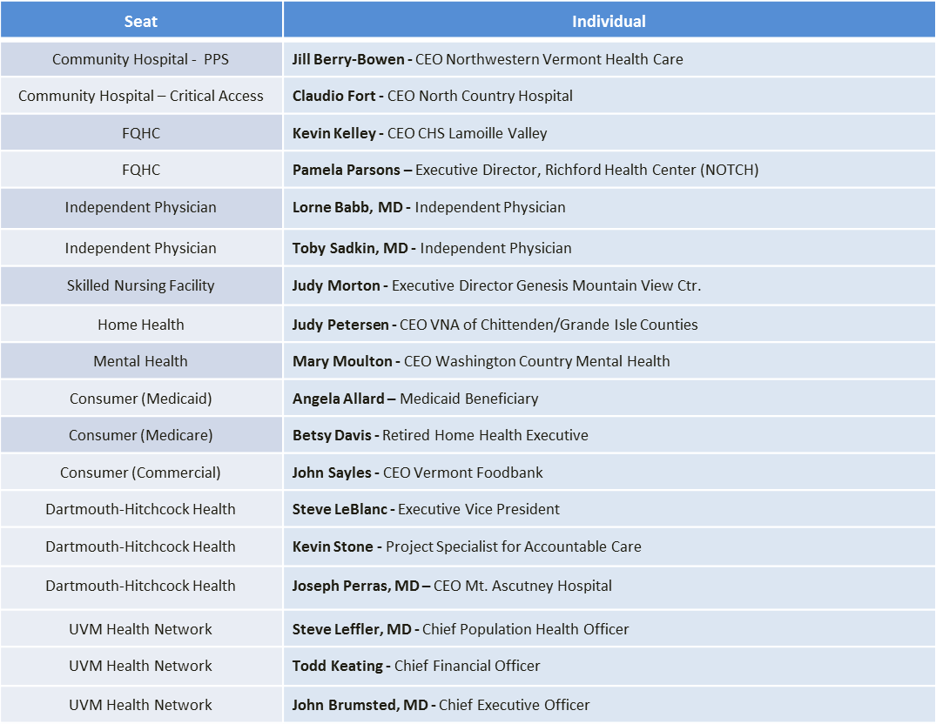
OneCare Vermont Board as of June 2017

